Jonathan DeBellis

Assets Anonymous

In our modern, technologically driven world, there are endless ways to go about managing and distributing one’s personal assets. Of these assets, an extremely important yet surprisingly poorly managed one, is cash. After all, “cash is king”. The increasingly complex financial landscape is becoming harder and harder to navigate and, for those who have begun the journey on their own, to manage. The average everyday person who is looking to enhance their financial security, whether they are just starting or have long been attempting to, can find this process difficult to keep track of. Perhaps they are attempting to expand their distribution in pursuit of an earlier and more stable retirement rather than just storing everything with one bank. To do this, the individual must keep track of important investments across multiple accounts, apps, and websites. Even some of the more well financially established individuals who wish to have a good idea of their financial outlook can face obstacles while trying to personally keep up with outsourced investments and deposits. Whether that be through financial advisors, treasuries, or banking services.

Not being able to see all different accounts and their values in one place can leave the individual with a poor understanding of their actual financial positioning. Being out of touch with one’s true financial standings can not only cause large amounts of anxiety, but it can also be detrimental to one’s performance while taking on the risks of diversifying a personal portfolio. It makes it more difficult to begin constructing a plan to save, invest, and spend wisely. Just seeing numbers on a screen that are scattered across different avenues, and not cold hard cash all together leaves a massive disconnect from the reality of one’s true situation. To add to the stresses of a treacherous and complex financial landscape, recent global events have triggered major consequences in supply lines causing high inflation accompanied by higher prices for energy and raw materials such as lumber. According to the US Bureau of Labor Statistics, the current US inflation rate sits at 8.5%, up 5.9% in only a year, and the price of energy has Table
correspondingly rise 32.9% in the same year.

With obstacles ranging from complex applications and websites that are extremely difficult to understand to an unstable global socioeconomic environment, the average American needs all the help they can get. With so many ways to borrow to get by in tough financial times such as these, American debt levels have been sky-high even after reaching their all-time peaks in the fourth fiscal quarter of 2019. The average American from the ages of 18-55 owns between 2-4 credit cards (Gonzalez-Garcia, 2021) and thus credit card debt alone now totals $887 billion as of February 2022 (Schulz, 2022).

Having to deal with and keep track of retirement accounts, personal investment accounts, bank accounts, credit and debit card balances, kids college savings accounts, and even subscriptions can be a headache for anyone. People need a better way to view and budget their accounts in a more structured manner. This will not only alleviate financial stress, but it will also make for more well-informed and clear-minded decisions. This is where Assets Anonymous (AA) comes in. The new personal finance helper app that will assist Americans with budgeting, structuring, tracking, and managing their assets, salaries, and expenses in a way that bests help them to be more financially stable going forward. The “anonymous” comes from the fact that none of the user’s personal information will be required to use the app.

AA will provide a very attractive ease of use benefit to its users. No hassle through signing up or worries for submitting personal information. A user will simply have to launch the app and enter in their financial standings for an outlook of their personal budget structure. Rather than having to use a pen and paper to track all avenues of cashflow, whether it be saving or spending, the user can view estimates of total yearly costs, take-home income, investments, debts, and net worth. The user only must enter his or her required statistics for the estimate they desire. Perhaps they are only concerned about net worth. In which case the user only needs to enter data that of which applies to the calculation of one’s personal net worth.

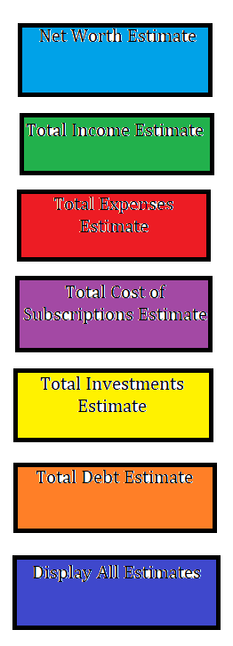The first prototype, although quite simple, can be a major help in keeping track of one’s financial status. Each of the buttons displayed on the left will display a broken up, structured view of the major areas that make up each of the estimates. The aesthetically pleasing and simple setup of AA will attract users from all age demographics who wish to budget in a more structured manner. The hands-on approach of self-entering data will give a strong sense of understanding to the user so that they may feel more comfortable of their financial situation after the birds-eye view and key insights provided by AA. Over time, AA’s promise to help structure the personal finances of its users will expand into more categories. These categories include offering budgeting suggestions and offering simple, well-tested, and well-known budgeting strategies based on the yearly income of the user.

The opportunity for growth in the personal finance industry is boundless. However, there are several constraints and risks that must be pointed out. Firstly, there are several major competitors in the personal finance industry that dominate certain market sectors. True Bill, for example, is a highly partnered company whose application gives its users a clear view of all their subscription services just as AA does. AA looks to capitalize on its flexibility and wide range of financial estimates and easy to use features to make up for its lack of partners.

A constraint upon usability comes in the form of user participation. With the gain of anonymity, the user loses the benefit of input automation. The user will have to enter in all their data regarding their total financial values of debts and type of debt, income, expenses and type of expense, and subscriptions. Many users will find this process tedious, and it will force them away from using the app and towards using multiple different automated apps for each of the different services offered by AA.

Works Cited

“CPI Home.” *U.S. Bureau of Labor Statistics*, U.S. Bureau of Labor Statistics, <https://www.bls.gov/cpi/>.

Fay, Bill. “Consumer Debt Statistics & Demographics in America.” *Debt.org*, 23 Feb. 2022, <https://www.debt.org/faqs/americans-in-debt/demographics/>.

Gonzalez-Garcia, Jamie. “Credit Card Ownership Statistics.” *CreditCards.com*, 16 Dec. 2021, <https://www.creditcards.com/statistics/ownership-statistics/>.

“A Look at the Shocking Student Loan Debt Statistics for 2022.” *Student Loan Hero*, 29 July 2022, <https://studentloanhero.com/student-loan-debt-statistics/>.

“Money Basics: Financial Problem Solving Strategies.” *GCFGlobal.org*, <https://edu.gcfglobal.org/en/moneybasics/financial-problem-solving-strategies/1/>.

Schulz, Matt. “2022 Credit Card Debt Statistics.” *LendingTree*, 22 Aug. 2022, <https://www.lendingtree.com/credit-cards/credit-card-debt-statistics/>.